





**Construction Permitting Determination Request**

**Quick Guide Instructions for**

**Iowa EASY Air**

Iowa Department of Natural Resources

Wallace State Office Building

Air Quality Bureau

502 E 9th St

Des Moines, IA 50319

Phone: (515) 725-8200

**Contact the Iowa EASY Air Helpdesk**

**Email:** [**easyair@dnr.iowa.gov**](mailto:easyair@dnr.iowa.gov)

**Or call (515) 725-9569 or (515) 204-3749**

# Table of Contents

Table of Contents 2

List of Figures 2

1. Adding the Determination Application to Your Account 3

2. Finding the Determination Request Application 6

3. Filling Out and Submitting a Determination Request Application 7

3.1 Form FI (Facility Information) 8

3.2 Determination 9

3.3 Form AF (Application Fee) 10

3.4 Attachments 10

3.5 Validation 12

3.6 Submission 12

# List of Figures

Figure 1 Dashboard Buttons to Create a New Submittal 3

Figure 2 Submittal Menu 3

Figure 3 Link to Submittal Types Associated with my Account 4

Figure 4 Available Submittal Types 4

Figure 5 My Account Menu 5

Figure 6 Basic Information Tabs 5

Figure 7 Associate Facility Button 5

Figure 8 Associate Facility Search 6

Figure 9 Facility Search Results and Adding Submission Type 6

Figure 10 Dashboard Buttons to Create a New Submittal 7

Figure 11 Submittal Menu 7

Figure 12 Construction Determination Icon 7

Figure 13 Facility Name and Contact Person Summary 8

Figure 14 Equipment Location and Mailing Contact Summary 9

Figure 15 Determination Summary 9

Figure 16 Form AF Screen 10

Figure 17 Attachment Screen 11

Figure 18 Upload Attachment Screen 11

Figure 19 Example Attachment Screen 11

Figure 20 Example Validation Screen 12

Figure 21 Example Certificate of Submission Screen 13

Figure 22 Confirmation of Submittal 13

This document is intended to provide directions on how to apply for a Determination Request in the Iowa EASY Air System.

(Note: This document is written to explain how a Responsible Official can submit an application for a Determination Request. As with other submittal types within the Iowa EASY Air system, the Responsible Official may delegate the completion of these forms to a Preparer. The Preparer can complete the forms and have the Responsible Official complete the certification and submit the application. The instructions for assigning a Preparer for a facility and submittal type are covered in other parts of the Iowa EASY Air documentation.)

# Adding the Determination Application to Your Account

Before you are able to apply for a Determination Request in the Iowa EASY Air system, you will need to add the Determination Request application to your account.

**Viewing Associated Application Types**

If you do not know what application types are associated to your account, you may navigate to the Air Department Submittal Type List page and view the submittal types associated with your account. There are two ways to the Air Department Submittal Type List page within the Iowa EASY Air system.

For one method, on your dashboard click on the “Apply for a New Submittal” button in the upper left-hand corner of the dashboard as shown in Figure 1.

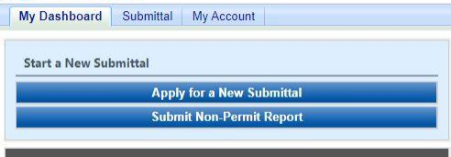

Figure 1 Dashboard Buttons to Create a New Submittal

Alternatively, hover over the Submittal dropdown menu and select “Start a New Submittal” as shown in Figure 2.

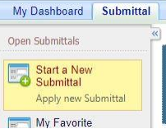

Figure 2 Submittal Menu

Next, you will see the application icons for the different types of submittals available to you in the system as shown in Figure 3.

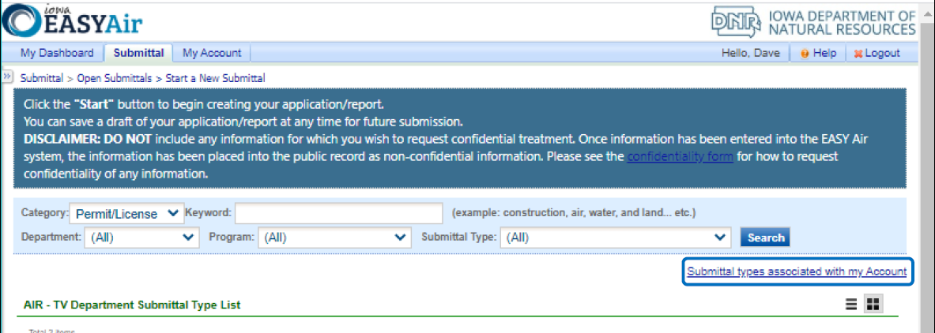

Figure 3 Link to Submittal Types Associated with my Account

Next, click on the link labeled “Submittal types associated with my Account” on the right side of the screen and the “Available Submittal Types” screen will appear as shown in Figure 4. On this screen, you are able to view the available submittal types and the submittal types already associated with your account.

A screenshot of the "Available Submittal Types". Two sections are shown, the "Available Submittal Types" and "Submittal Type Association Instruction".

Figure 4 Available Submittal Types

If you don’t see the Determination Request application associated with your account, click on “Add More”. This will take you to the “Basic Information” page. Follow the instructions below to associate the application type.

**Associate an Application Type**

To associate an application type to your account, you will need to navigate to the “Associate Facilities” tab. To navigate to the “Associate Facilities” tab, on your dashboard hover on “My Account” and click on “Basic Information” as shown in Figure 5.

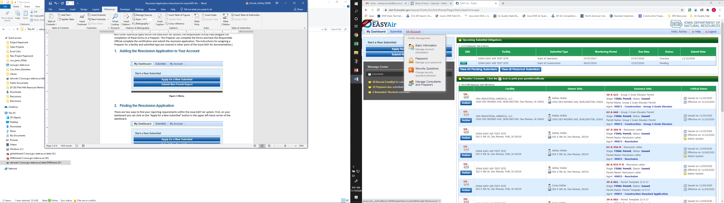

Figure 5 My Account Menu

The Basic Information page will appear. As shown in Figure 6, this page will have four tabs on top. Click on the “Associate Facilities” tab. This tab will show all your associated facilities and application types you currently have on your account.

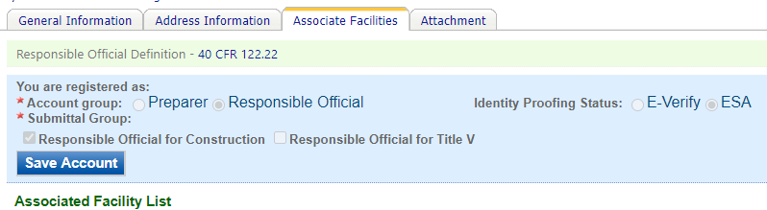

Figure 6 Basic Information Tabs

Next, scroll to the bottom of the page and you should see three buttons, as shown in Figure 7 below. Please click on “Associate Facility”.

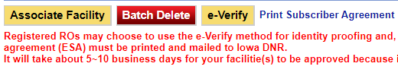

Figure 7 Associate Facility Button

The facility search will appear as shown in Figure 8 below. Enter in your facility information and click, “Search”. You may search by Facility Name, Address, or Facility Number.

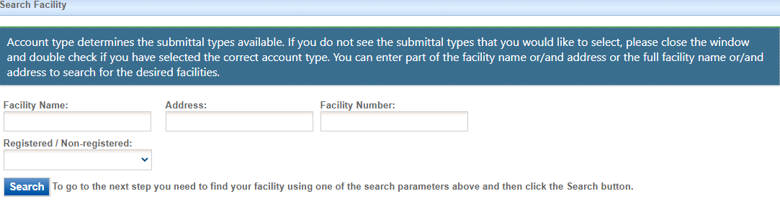

Figure 8 Associate Facility Search

The facility information will appear below the facility search as shown in Figure 9. Select the check box for the facility and the “Construction Determination” check box under submission type.

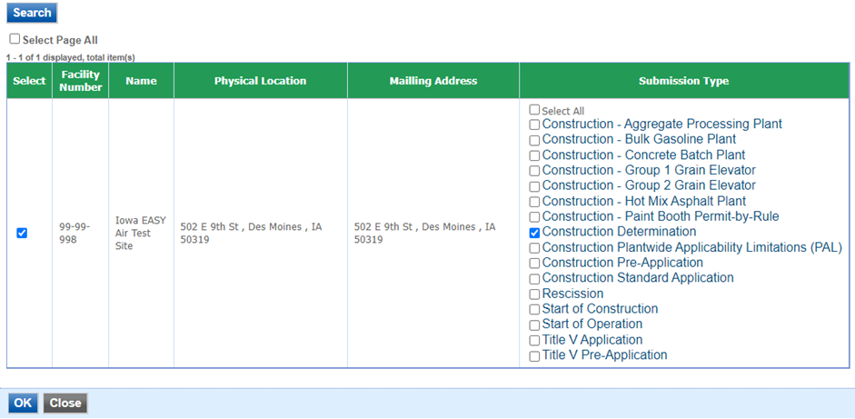

Figure 9 Facility Search Results and Adding Submission Type

Next, click “Ok” and then click “Close”. This will associate the Determination Request application to your account. If you went through the e-Verify subscriber agreement process when you set up your account, you will be able to use the Determination Request application after this step. However, if you sent in the paper subscriber agreement form, you will have to wait until the Iowa EASY Air Administrator completes the association of the Determination Request application to your account. You will receive an email from the Iowa EASY Air Administrator when the association of the Determination Request application has been made to your account.

# Finding the Determination Request Application

There are two ways to start an application within the Iowa EASY Air system. For one method, on your dashboard you can click on the “Apply for a New Submittal” button in the upper left-hand corner of the dashboard as shown in Figure 10.



Figure 10 Dashboard Buttons to Create a New Submittal

Alternatively, hover over the “Submittal” tab and select “Start a New Submittal” as shown in Figure 11.



Figure 11 Submittal Menu

Next, you will see the application icons for the different types of submittals available to you in the system. The Construction Determination icon is shown below in Figure 12. Please select “Start” at the bottom right hand corner of the icon to start the Determination Request application.

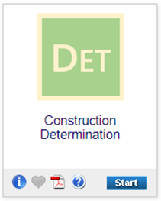

Figure 12 Construction Determination Icon

# Filling Out and Submitting a Determination Request Application

According to 567 Iowa Administrative Code (IAC) 22.1(3)”a”; if requested in writing, the Iowa DNR will review the design concepts of equipment and associated control equipment prior to application for a construction permit. The determination request is primarily for determining the acceptability of the location of the equipment, but has been expanded to cover regulatory applicability questions, determination on whether a modification to an existing construction permit would be required, reviews of small unit exemption documents, and determination on whether a construction permit would be required for equipment. The EASY Air application for a determination request has been designed for the applicant to describe the requested review and attach the applicable documents to complete the review.

## Form FI (Facility Information)

Next, the Form FI: Facility Information screen will appear (see Figure 13 and 14). Please click on the “Company/Facility Name:” dropdown menu and select the Company/Facility Name that the determination request should be completed for. The facility address, facility number, field office number, and current billing status will auto-fill. If the facility information is not correct, please contact [easyair@dnr.iowa.gov](mailto:easyair@dnr.iowa.gov) to change the facility information.

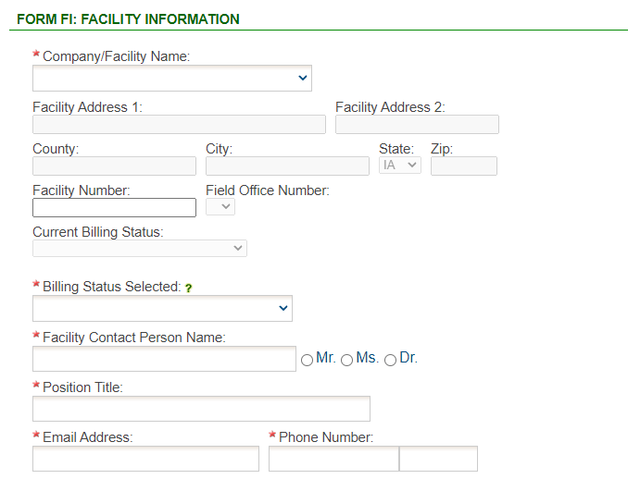

Figure 13 Facility Name and Contact Person Summary

The “Billing Status Selected:” field should be used to indicate the actual billing status for the facility if the “Current Billing Status” is incorrect. If the “Current Billing Status” is correct, please select the same billing status under “Billing Status Selected”. If you have any questions about your facility’s billing status or Air Quality Fees, please visit the DNR webpage [Air Quality Fees](https://www.iowadnr.gov/Environmental-Protection/Air-Quality/Air-Quality-Fees).

Please provide the name, position title, and contact information for the person within the company who should be contacted regarding questions or other pertinent information related to the determination request application.

Please provide the address for where the equipment will be or is already installed. If the equipment is portable, please use the staging area address. If the equipment is located at the same address as the facility, select the “Same as Facility Address” checkbox, and the information will be copied from the facility address information.

Please provide the name, position title, contact information, and mailing address for the person within the company who should be mailed the final determination. If the person who should be mailed the final determination is the same person as the Facility Contact, select the “Same as Facility Contact” checkbox and the information will be copied from the facility contact information. If the mailing address for the person who should be mailed the final determination is the same as the facility address, select the “Same as Facility Address” checkbox and the information will be copied from the facility address information.

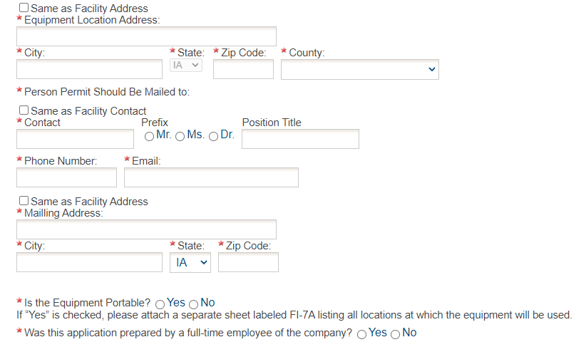

Figure 14 Equipment Location and Mailing Contact Summary

If the equipment is portable (such as a portable asphalt plant), please select the “Yes” radio button. If the portable equipment will be used in other locations, attach a separate sheet labeled FI-7A in the Attachments section to list all locations known at the time of application submittal.

If the application was prepared by a full-time employee of the company, please select the “Yes” radio button. If the application was not prepared by a full-time employee of the company, the permit preparer information must be filled out. Any permit preparer that is not a full-time employee of the company must be a licensed Professional Engineer (P.E.) in the State of Iowa (567 IAC 22.1(3)”b”). A P.E. signature document must also be attached to the submittal in the Attachments section. The P.E. number may be verified at the [License Search Page](https://iowaplb.force.com/LicenseSearchPage).

Once you have finished entering the information, click “Save” and then “Next”. If there is required information missing from the section, the Iowa EASY Air system will highlight the required fields in red. You may proceed with the application, but the system will not allow you to submit the application until all the required fields are completed during the Validation step.

## Determination

Next, the Determination screen will appear (see Figure 15). Please provide a brief description in the “Determination Description” text box. If you plan to attach your determination request description to the submittal, please enter “See attachments” in the text box and attach your description in the Attachments section. If you are attaching any documents to the application, check the box labeled “Check if you are submitting an attachment”.

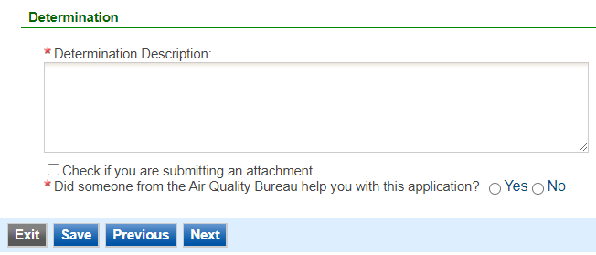

Figure 15 Determination Summary

If someone at the Air Quality Bureau helped you complete this application, please select the “Yes” radio button. Please select the Air Quality Bureau staff member who assisted you with completing the application using the drop-down menu that appears. If the person who helped you is not on this list, please use the “Other Staff Name” text box to enter the staff name.

Once you have completed all the required fields, please click on “Save” and then “Next”.

## Form AF (Application Fee)

Next, the Form AF (Application Fee) screen will appear if the “Billing Status Selected” is “Major Source – Hourly Fee” (see Figure 16). This form is not required if the “Billing Status Selected” is “Minor Source – Fee Per Application”.

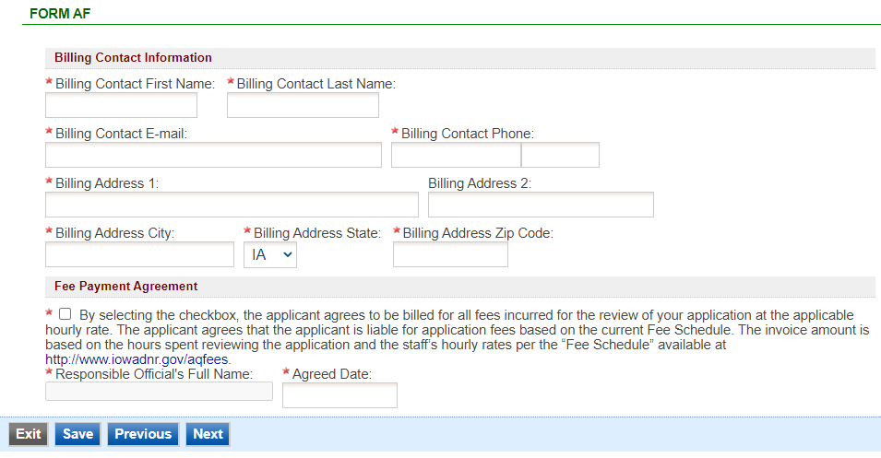

Figure 16 Form AF Screen

If this form is applicable, please enter the contact information for the person who should be contacted regarding billing for the review of the determination request materials. Please review the fee payment agreement carefully and check the box indicating that you agree to be billed for all fees incurred for the review of your application at the hourly rate, then enter the Responsible Official’s Full Name and date. Once you have finished entering the information, click “Save” and then “Next”.

## Attachments

Next, the Attachments screen will appear (see Figure 17). Please upload the required attachments to the application and any other attachments at this screen.

Attachments may be uploaded to the application electronically, or mailed/faxed to the Department.

The Iowa DNR recommends that attachments be submitted electronically so as to not slow down the application process.

Please attach any documents required to assist the assigned engineer with completing the project on this screen.

To include your attachment(s) in the Iowa EASY Air system, select the “Online” radio button and then click on the “Upload” button. Only one file may be uploaded at a time, and the maximum file size allowed is 100 MB. The example attachment screen shown below may appear differently depending on what was selected earlier in the application in the Form FI screen.

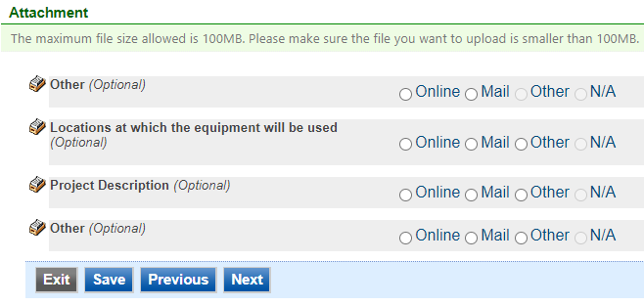

Figure 17 Attachment Screen

Select “Choose File” to select the document to be uploaded (see Figure 18). These file types are accepted by the system:

* pdf, doc, docx, txt, xls, xlsx, cvs
* jpeg, jpg, bmp, png, gif
* xml

You may include a comment for each attachment. When you have successfully selected the document, click on “Save” to upload the attachment.

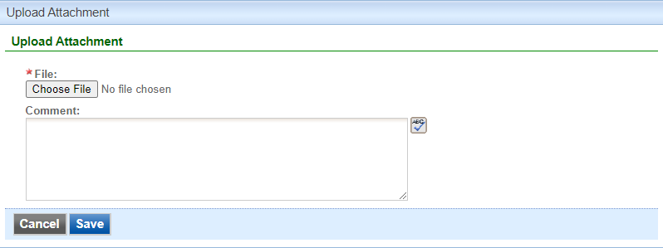

Figure 18 Upload Attachment Screen

The uploaded attachment will display on the screen as shown in Figure 19. To remove an attachment, click the red “x” icon. The Iowa EASY Air system will confirm with you that you want to delete the record with a pop-up message. Select “Ok” on this message to confirm, or “Cancel” to stop the deletion request. To edit the attachment comment, click on the attachment comment, edit the comment, then select “Save” to update the comment or “Cancel” to cancel the change.

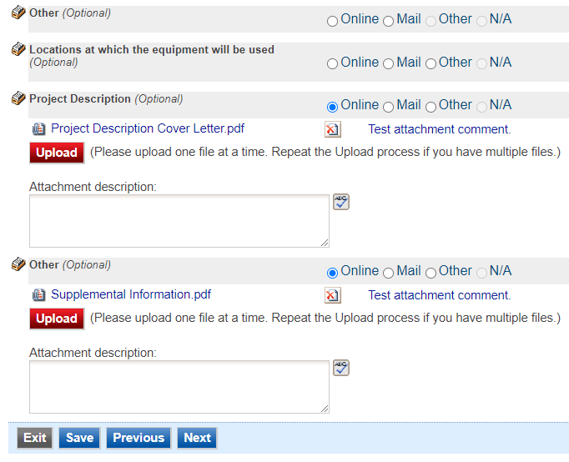

Figure 19 Example Attachment Screen

Please click “save” at the bottom of the screen to save the page.

If you do not click “save” before loading into another page, you will lose your current progress entering information.

If you plan to mail or fax the attachments, please select the “Mail” radio button on the attachment screen. If mailing attachments, include the attachment descriptions and submittal ID. Mail attachments to the following address:

Application Login Desk

Air Quality Bureau

502 E 9th Street

Des Moines, IA 50319

Please select “Other” if you wish to submit the document a different way, such as hand delivery, fax, or describe the reason in the comment text box. If faxing documents, include the attachment descriptions and submittal ID. The Air Quality Bureau fax number is (515) 725-9501.

## Validation

Next, the Validation screen will appear (see Figure 20). The system will check the application forms for required information that is missing, and will display a result similar to the figure below:

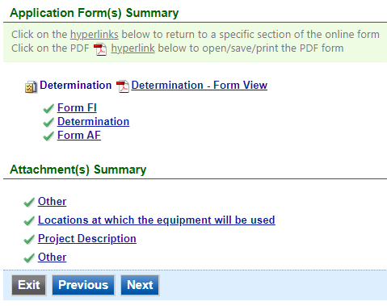

Figure 20 Example Validation Screen

If there are no noted issues, click the “Next” button. If there are issues, you may navigate to the section by selecting the section on this screen to complete the missing information.

Please note that the system will only check for missing information, and will not validate whether the information is complete or accurate.

## Submission

Next, the Certification of Submission screen will appear (see Figure 21). Please review the statement at the top of the screen, then check the box at the top of the screen, answer the security question, enter your pin, and click “Submit”.

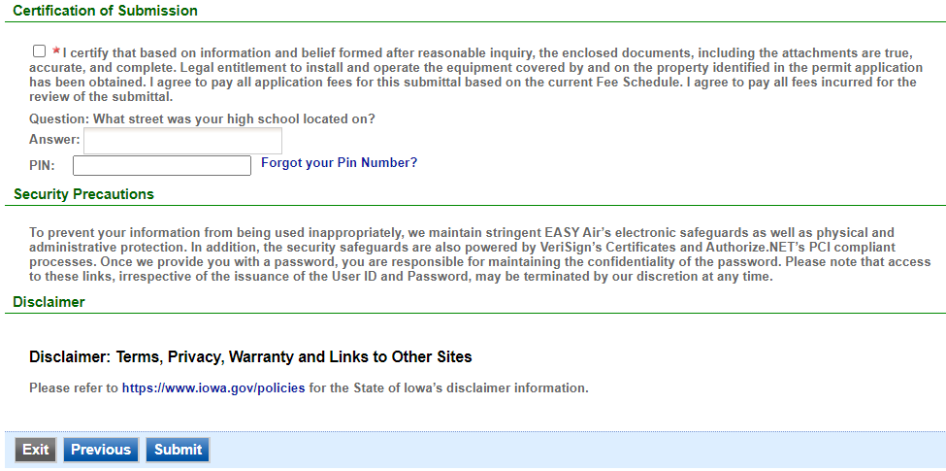

Figure 21 Example Certificate of Submission Screen

You will get a confirmation screen similar to the one shown below in Figure 22 and a confirmation email will be sent to you.

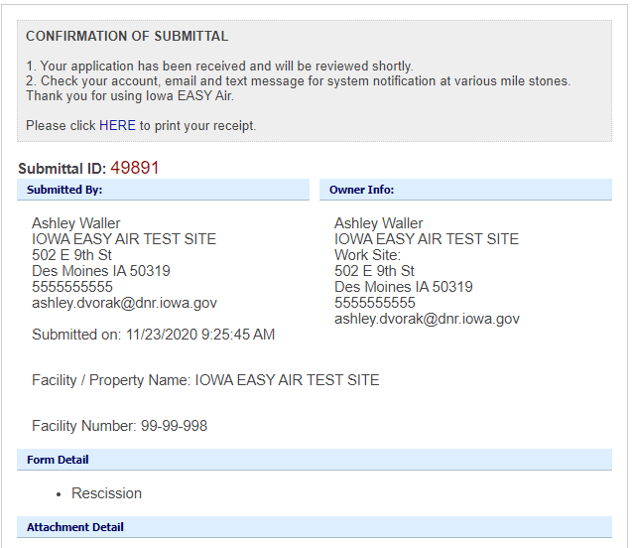

Figure 22 Confirmation of Submittal

**If you have questions, please call the Iowa EASY Air Helpdesk  
at (515) 725-9569 or (515) 204-3749.**

**Or, send an email to** [**easyair@dnr.iowa.gov**](mailto:easyair@dnr.iowa.gov)